
SHIRE HIGHLANDS EDUCATION DIVISION
2026 MALAWI SCHOOL CERTIFICATE OF EDUCATION MOCK
EXAMINATION

CLOTHING AND TEXTILES
Subject number: M034/II
Wednesday, 11th March Time allowed: 8:00-8:45 am
(45 minutes)
Preparation session (Cutting out)
Practical Session: 2hr 30 minutes
(Time as arranged)
PAPER II
(55 MARKS)
Instructions:
- This paper contains 4 printed pages. Please check.
- You are advised to study the question paper carefully with the sketch, the pattern, and the fabric before beginning to cut out.

A pattern of a toddler’s dress is provided. You are required to cut out and make up the garment as required.

Materials provided
- Pattern of a toddler’s dress
A Bodice back
B Bodice front
C Sleeve
- 100 cm x 110 cm printed cotton poplin fabric
- Matching cotton sewing machine thread
- Personal sewing equipment
- Adequate pressing facilities
- Small button

PREPARATION: Cutting out sessions (45 minutes)
LAYOUT
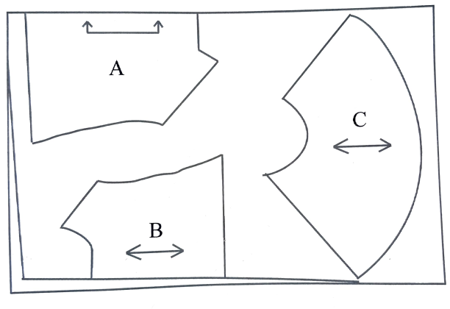

- To prepare the pattern, separate the three pattern pieces.
- Following the layout, pin and cut one bodice back, two bodice front and two sleeves.
- After cutting-out, transfer all the essential pattern markings to the fabric.

NOTE: Seam allowances are 1.5 cm.

Make up the dress as follows:

- Tack and edge stitch one sleeve using machine stitch. Press.
- Tack and edge stitch the bodice front 0.5 cm from edge.
- Fold the edged side of the bodice front dot to dot. Press and stay stitch at neckline and hemline.
- Tack and join the sleeve to bodice back using open seam. Press seam open.
- Tack and join sleeve to bodice front using open seam. Press seam open. Neaten using machine stitch.
- Tack and edge stitch the neckline from the centre front through the joined sleeve to the centre back.
- Tack and join the side seam from sleeve edge to dress hem using machine stitch. Neaten 10 cm from hem using loop stitch.
- Using a hand sewing needle, attach a loop and button.
- Tack and slip hem 5 cm from the centre front.
- Press.

At the end of the test, any unassembled parts of the garment should be tacked to a single part of the garment. All pins and needles should be removed from the work.
Sew on to your test a label bearing examination number. This label should not cover any stitching and should be on a single layer of fabric.
Fold your work carefully and place it in an envelope provided.
Do not put in scraps of fabrics left over after cutting.

END OF QUESTION PAPER
NB: This paper contains 4 printed pages.

